CAD21 Sim. Exercises (analogue circuits).

1. Passive Crossover
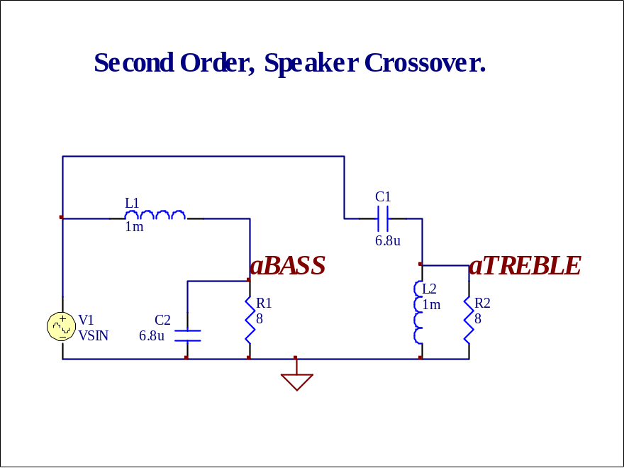

BODE Plot (Log.f, dB); 1V, 10Hz to 100kHz, 100 points per decade (ac analysis).
TRANSIENT; 1V, 100Hz. 3 cycles.

- Active Filter.
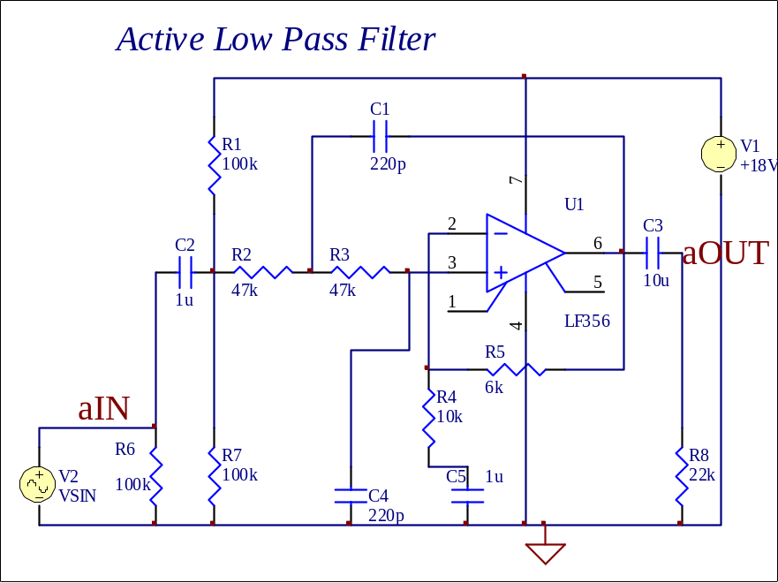

BODE plot, 100mV, 10Hz to 100kHz.
Change R5 to 8k, 10k, 12k, 16k, 20k, and observe change in graph as gain is increased.
3. Transistorised Pre-amp.
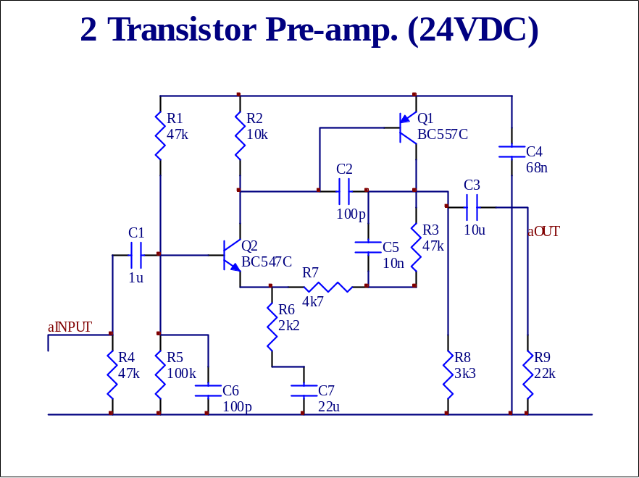

BODE plot, 20mV input, 20Hz to 20kHz.
Transient, 50mV, 6kHz.
Show ALL the transistor DC voltages.

4. Sinewave Oscillator
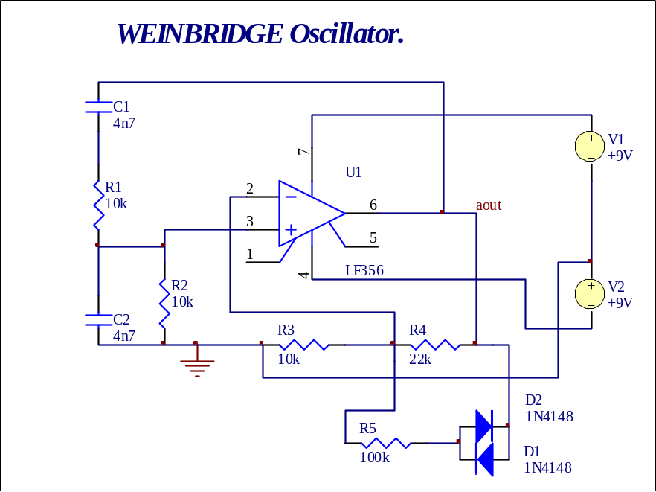

TRANSIENT only. MUST be set accordingly ( experiment with STOP time; eg. 100ms; also INITIAL conditions )

